**Power BI**

**Hands-On Assessment**

**Name:** Aayush Tomar

**Shell Email ID:** [Aayush.Tomar@shell.com](mailto:Aayush.Tomar@shell.com)

**Data Loading**

Sql Server:

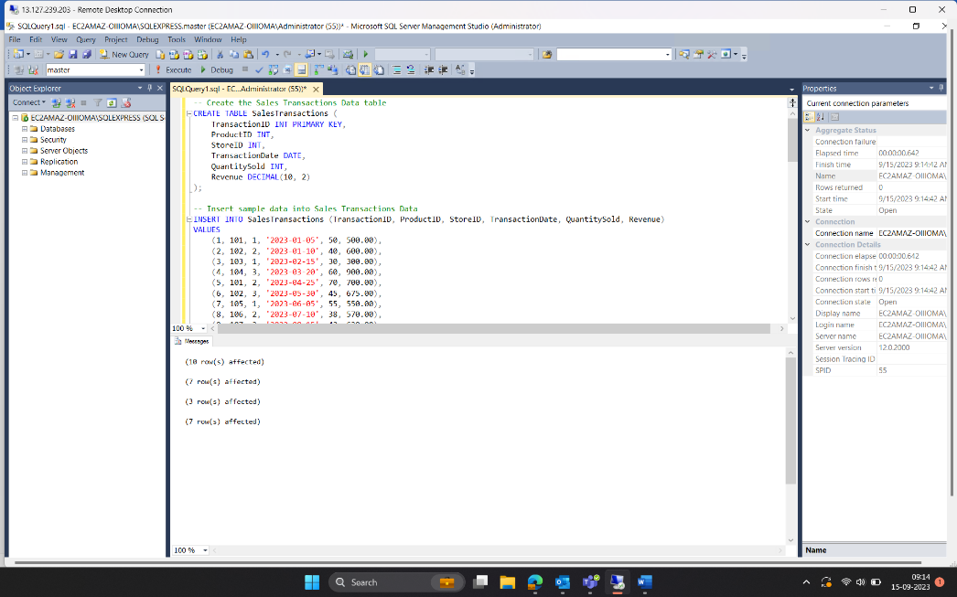

Power BI:

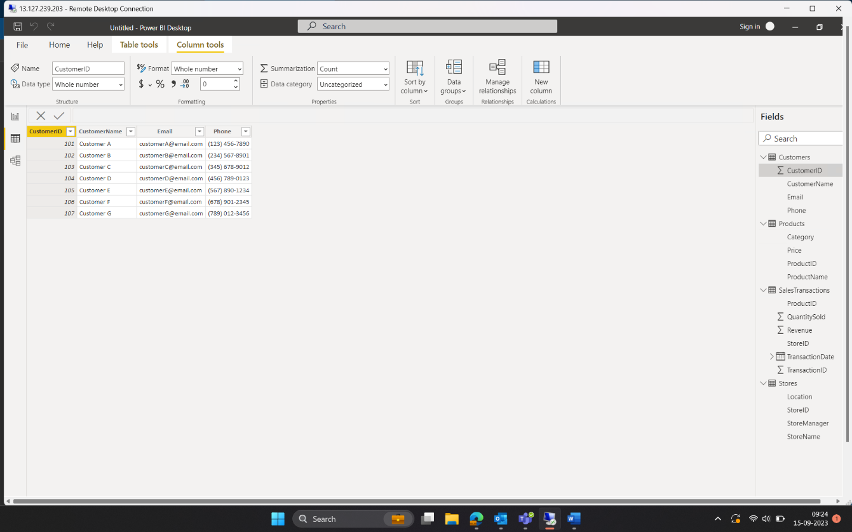

**Transform Data**

Merge Tables:

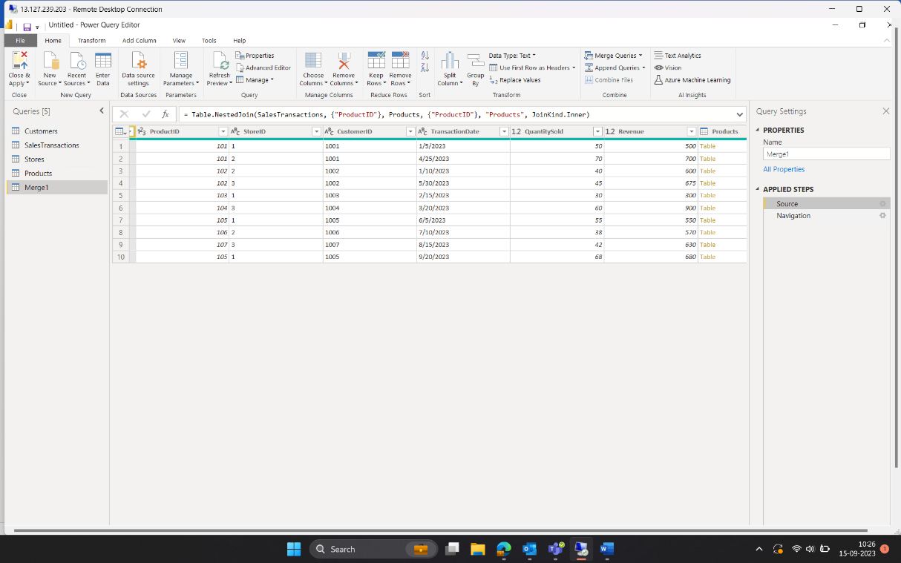

Data Cleaning:

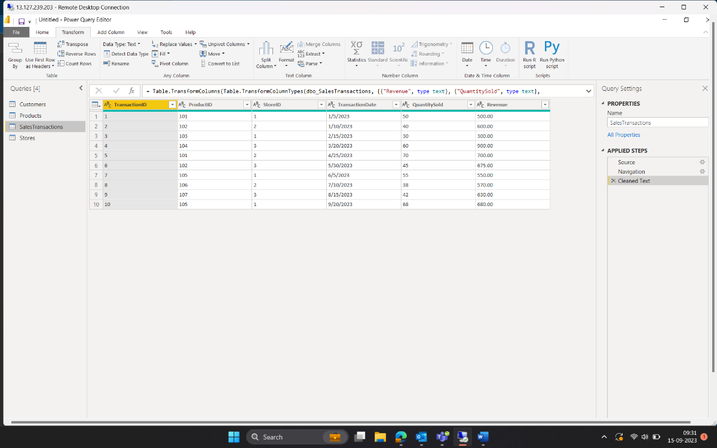

Calculated Column:

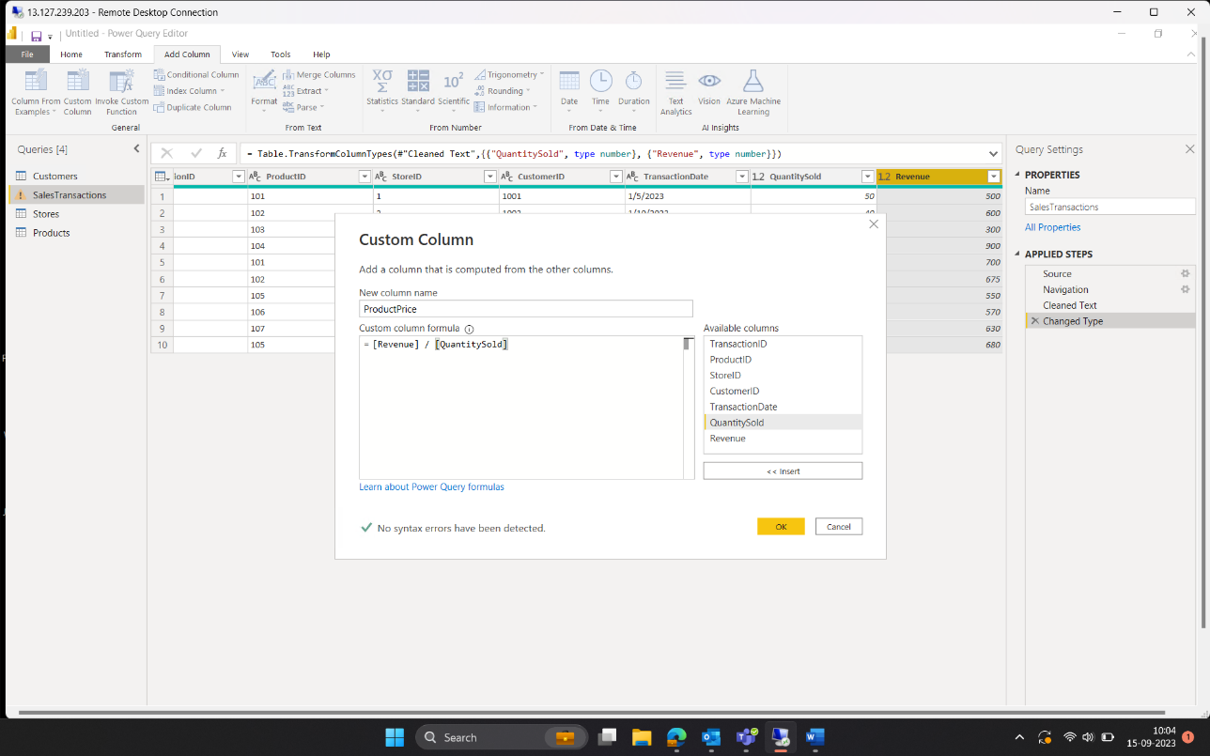

Filter Values:

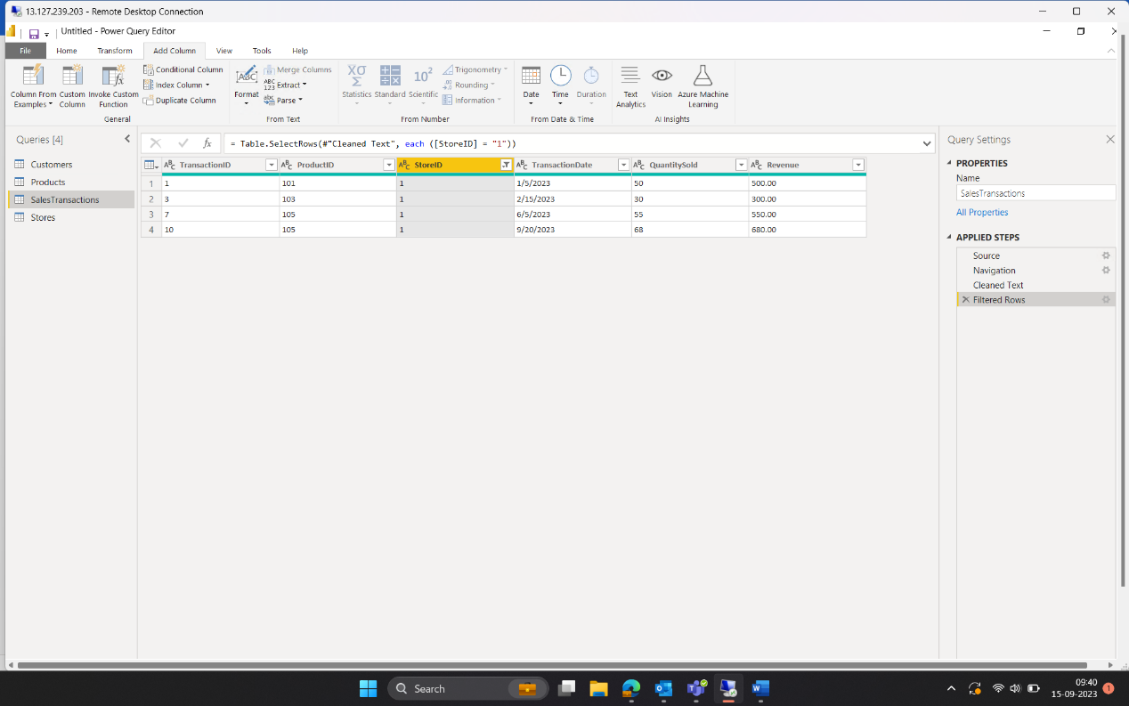

**Data Modelling**

Relationships

**Business Queries**

Q1.:

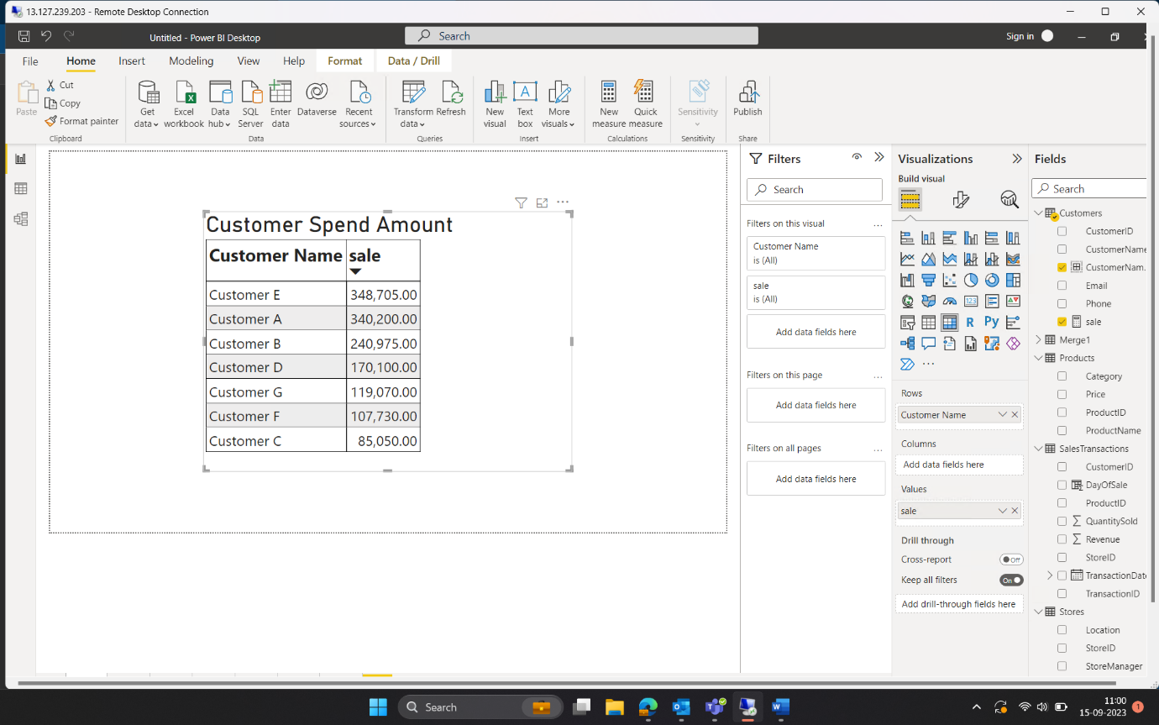

Q2.:

Q3.:

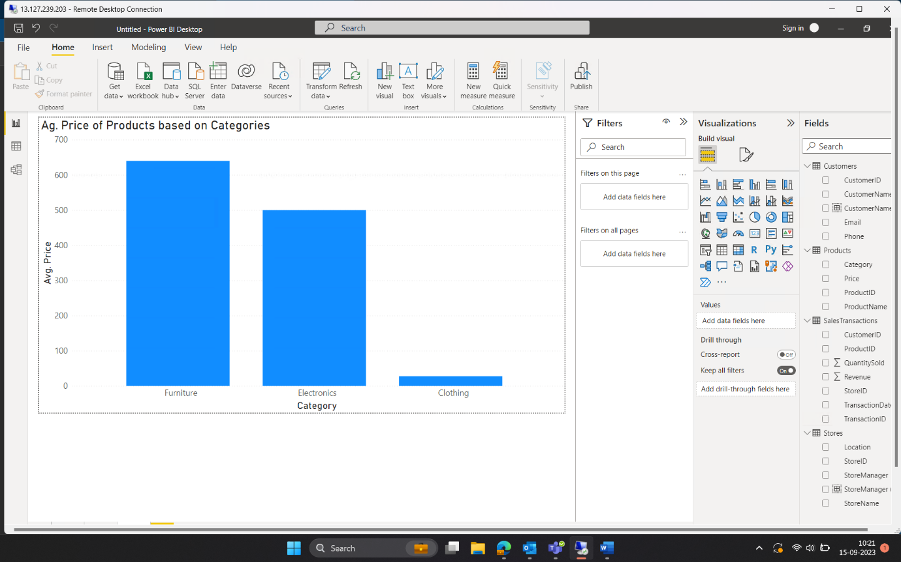

Q4.:

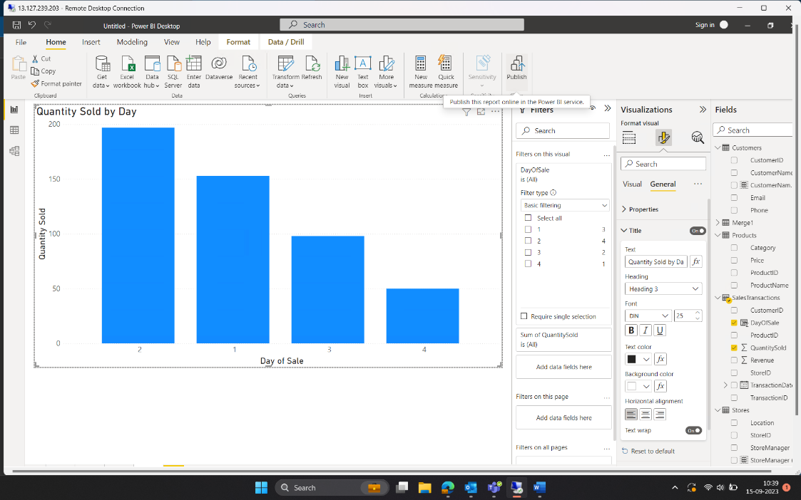

Q5.:

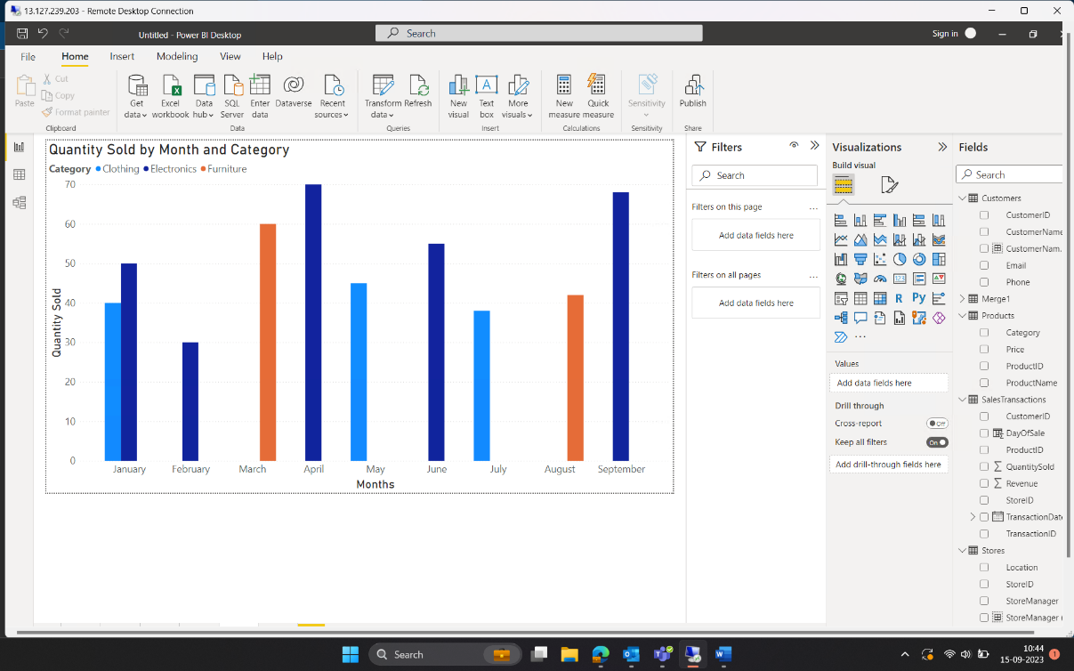

Q6.:

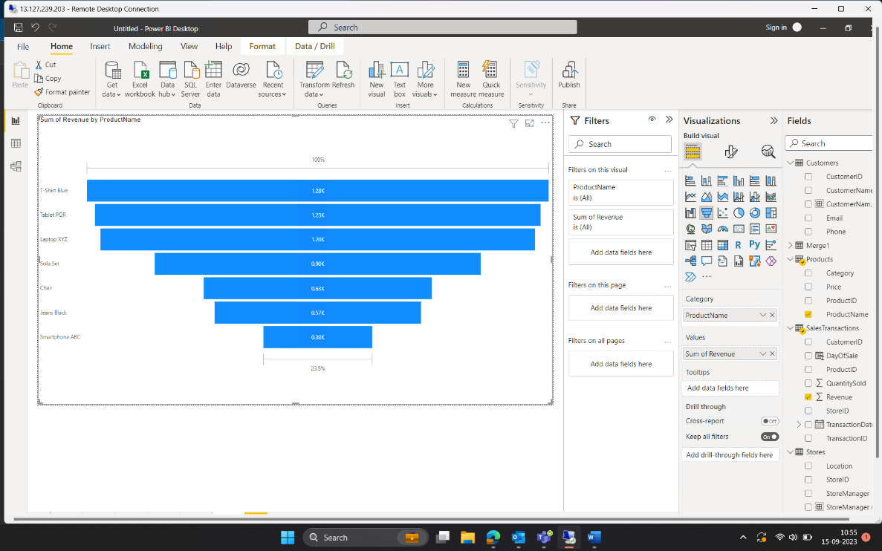

Q7.:

Q8.:

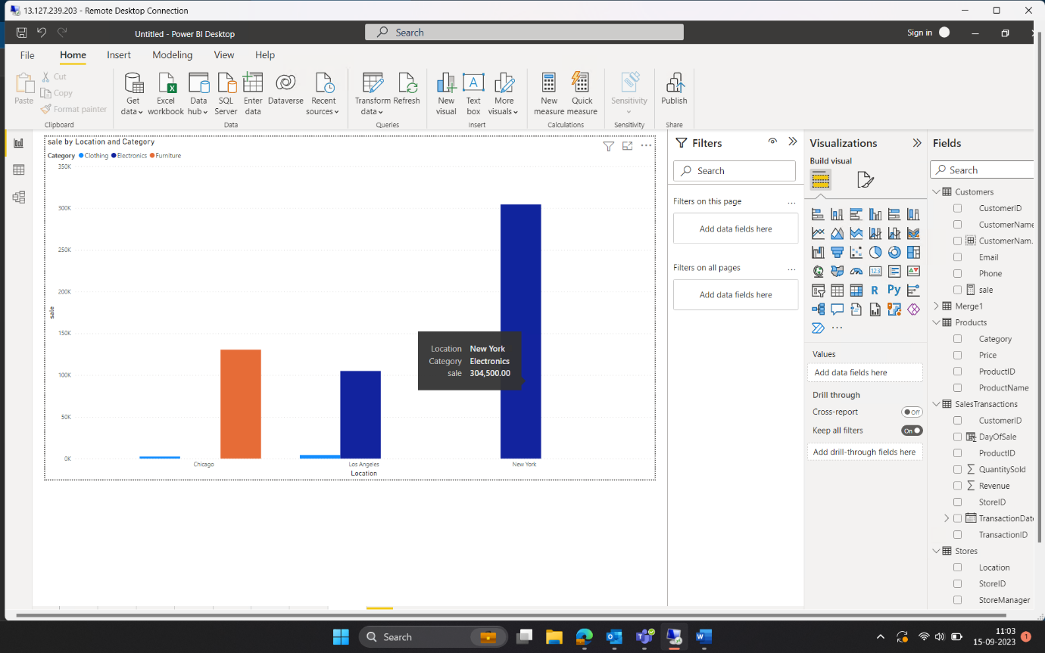

Q9.:

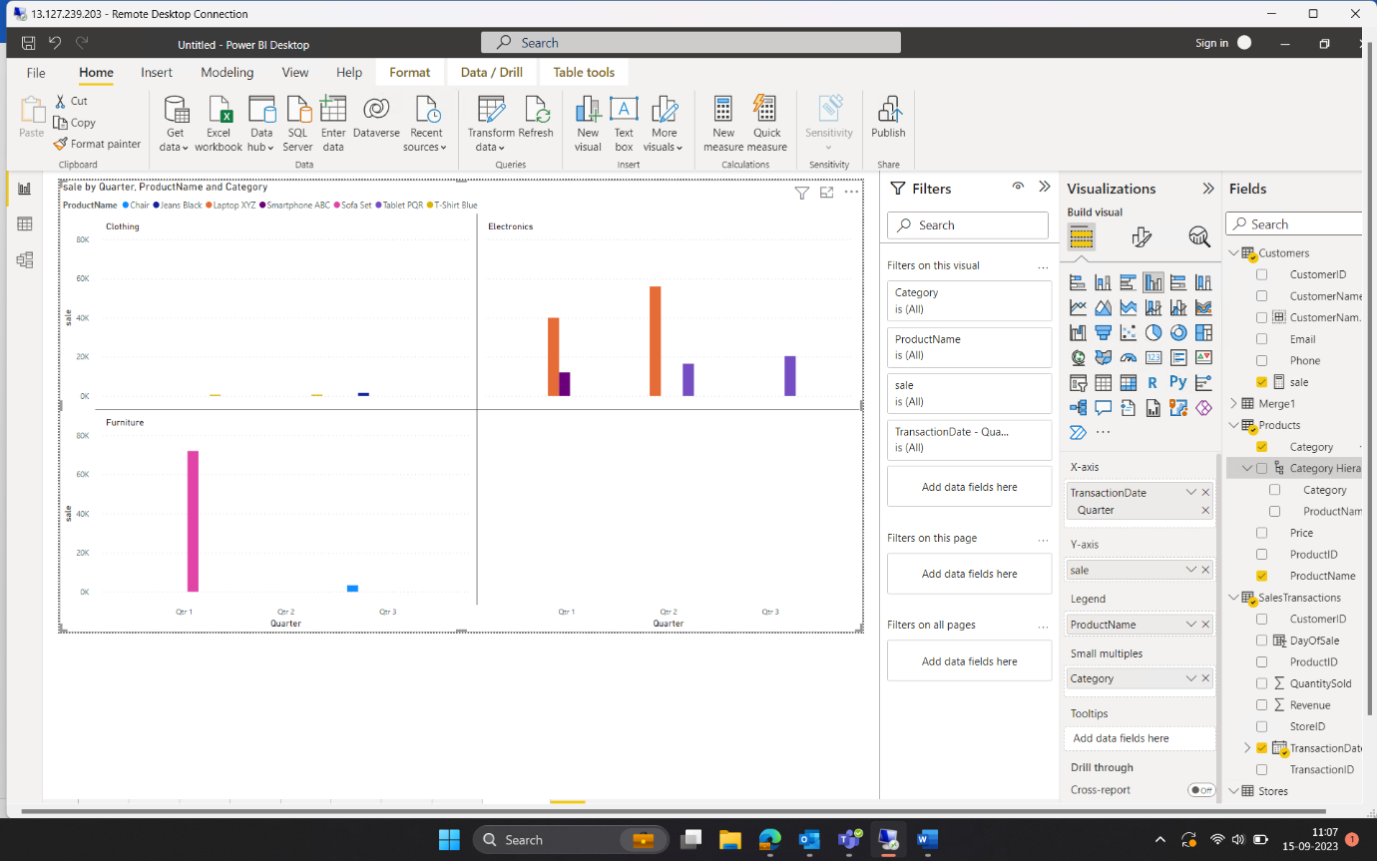

Q10.:

